**553/2**

**BIOLOGY**

**(Practical)**

**Jul/Aug 2019**

**2 Hours**



**MUKONO EXAMINATION COUNCIL**

**Uganda Certificate of Education**

**BIOLOGY PRACTICAL**

**Paper 2**

**2 Hours**

**INSTRUCTIONS**

*Answer* ***all*** *questions.*

*Drawings and answers should be made in the spaces provided.*

*Use sharp pencils for your drawings.*

*Crayons and coloured pencils should* ***NOT*** *be used.*

*No additional sheets of writing paper are to be inserted in the booklet.*

|  |  |  |
| --- | --- | --- |
| **QUESTION** | **MARKS** | **SIGN & EXAMINER’S No.** |
| 1 |  |  |
| 2 |  |  |
| 3 |  |  |
| TOTAL |  |  |

1. You are provided with the following specimen T, Solution A solution B, Solution C; using a cork borer produce 4 cylinders of tissues from specimen T, cut the cylinders to a uniform length of 4cm each
2. Place one cylinder of tissue in each solution A, B, and C and leave one exposed to air leave the set up for 1 hour.
3. Remove the tissue cylinders and dry them gently using a filter paper to remove excess solution ;

* measure and record the final length
* feel each cylinder and record their texture in the table below
* Calculate the percentage change in length for each cylinder and record in the table 1 below.  ***(8marks)***

|  |  |  |  |  |
| --- | --- | --- | --- | --- |
| Cylinder of potato | Initial length | Final length | Percentage change in length | Texture |
| Solution A | 4.0 |  |  |  |
| Solution B |  |  |  |  |
| Solution C |  |  |  |  |
| Air |  |  |  |  |

1. Name the process responsible for your results above ***(1mark)***

-----------------------------------

1. Plot a graph of percentage change in length varying with sucrose solutions  ***(7marks)***

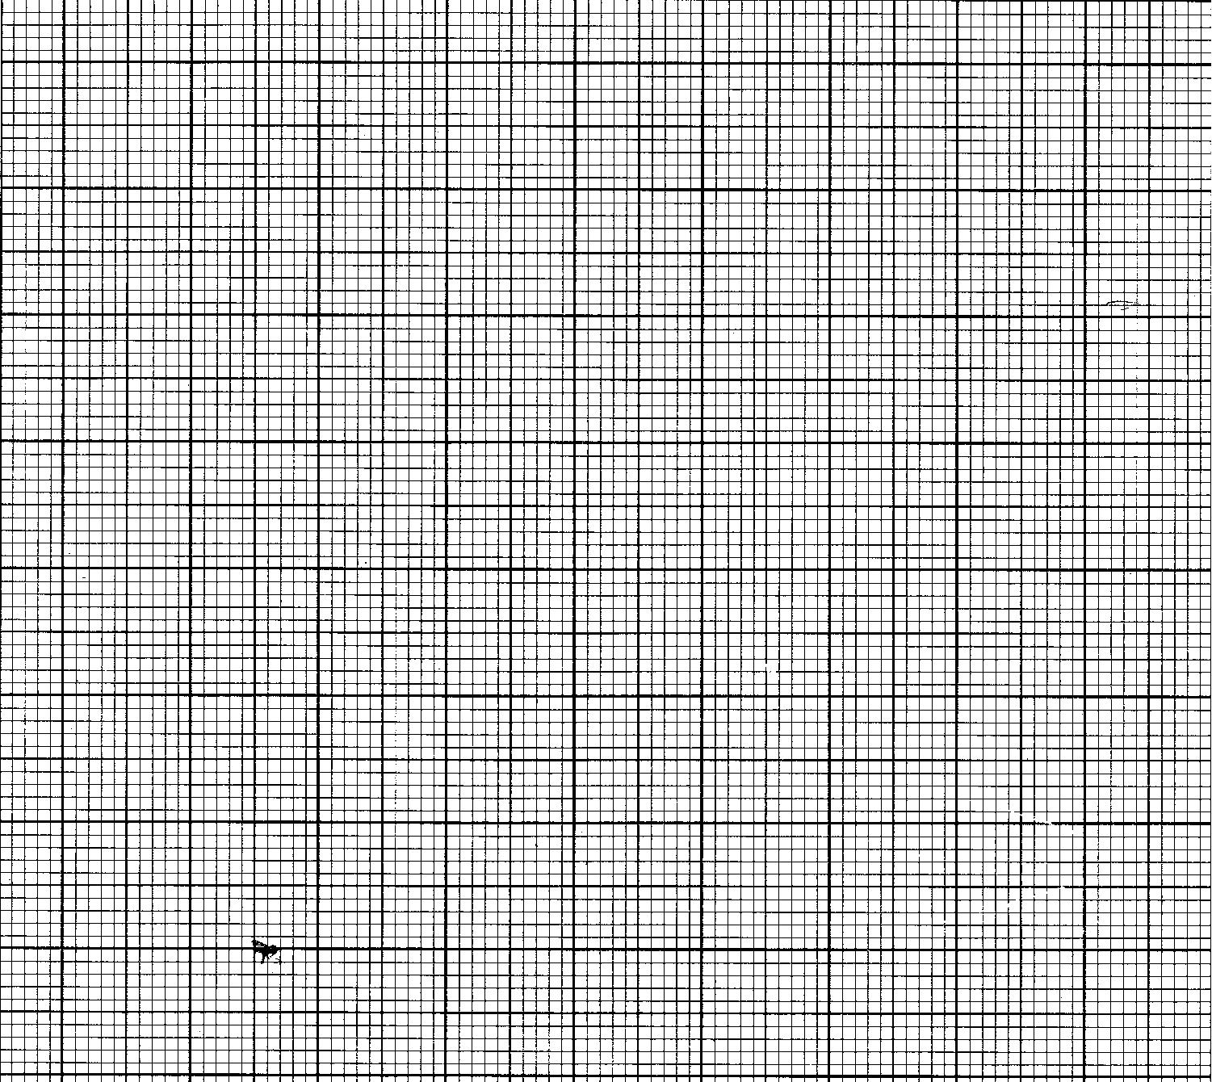

1. Explain the observations made in the cylinder placed in each of the solution:

Solution B  ***(2marks)***

…………………………………………………………………………………………………………………………………………………………………………………………………………………………………………………………………………………………………………………….........................................................................................................................................................................

solution C ***(2marks)***

………………………………………………………………………………………………………………………………………………………………………………………………………………...............................................................................................................

1. Arrange solution A, B and C in order of increasing osmotic potential ***(1mark)***

…………………………………………………………………………………………………………………………………………………………………………………………………………………………………………………………………………………………………………………….........................................................................................................................................................................

1. What is the significance of your observations about the role of water in plant tissues

***(1mark)***

…………………………………………………………………………………………………………………………………………………………………………………………………………………………………………………………………………………………………………………….........................................................................................................................................................................

1. You are provided with specimen F. Study it and answer the questions that follow
2. (i) To what phylum and class does specimen F belong

Phylum  ***(1Mark)***

…………………………………………………………………………….........................................................................

Class  ***(1Mark)***

…………………………………………………………………………….........................................................................

1. Identify three structural features which are used to place specimen F in the class you have given ***(3Marks)***

…………………………………………………………………………………………………………………………………………………………………………………………………………………………………………………………………………………………………………………….............................................................................................................................

.......................................................................................................................................................................................

1. (i) Suggest the habitat of specimen F ***(1Mark)***

…………………………………………………………………………….............................................................................

(ii)using observable features only, describe the structural adaptations of specimen F to its habitat  ***(4Marks)***

…………………………………………………………………………………………………………………………………………………………………………………………………………………………………………………………………………………………………………………......................................................................................................................................................

.............................................................................................................................................................................................

1. Cut and remove the operculum from one side
2. Draw and label the features observed from the cut side.  ***(4Marks)***
3. Carefully cut out and remove the gill. Draw and label one gill removed. ***(4Marks)***
4. In what ways is the gill labeled above adapted for its function  ***(3Marks)***

…………………………………………………………………………………………………………………………………………………………………………………………………………………………………………………………………………………………………………………….............................................................................................................................

1. You are provided with specimen N, O,P,Q. Examine the specimens carefully and answer the following questions.
2. List the specimen which are
3. wind pollinated ***(1Mark)***

…………………………………………………………………………………………………………………………………………………………...........................................................................................................................................................

1. insect pollinated ***(1Mark)***

…………………………………………………………………………………………………………………………………………………………...........................................................................................................................................................

1. Suggest the mechanism of pollination of specimen Q and give **five** adaptive features to this mechanism.

Mechanism……………………………………………………………… ***(1Mark)***

Adaptation ……………………………………………………………… ***(5Marks)***

…………………………………………………………………………………………………………………………………………………………………………………………………………………………………………………………………………………………………………………………………………………………………………………………………………………………………………………………………………………………………………………………………………………………………………………………………………………………………………..................................................................

1. Give 3 structural differences between specimen **N** and **P** ***(3Marks)***

|  |  |
| --- | --- |
| Specimen **N** | Specimen **P** |
|  |  |
|  |  |
|  |  |

1. Make a longitudinal section through specimen **N**. Draw and label ***(8Marks)***

***End -***